Indicative Costs to Contributors for the HNS Fund Secretariat

States considering accession to the 2010 HNS Convention often request information on the anticipated costs of administering the HNS Fund once the Convention enters into force. This note sets out indicative figures based on current Secretariat costs. However, the final amounts and frequency will be decided by the HNS Fund Assembly, comprised of representatives of the States that are parties to the Convention. Prospectively estimating the cost of operating the HNS Fund is challenging due to several unknowns, including the number of contributors, cargo volumes, and the types and severity of potential incidents.
At the outset, it is important to recall that the HNS Fund will share administration and office space with the IOPC Funds Secretariat in London, using the same Director and leveraging existing systems and infrastructure. This arrangement will minimise setup costs and require only a small number of additional staff to administer the Convention, thanks to the expertise already present within the Secretariat.
Types of Levies
Activities to support the operation of the HNS Fund will be funded from two different levies:
- Initial contribution: one-off, paid by contributors in each State on becoming a Party. It covers the Secretariat setup, working capital, and repayment of the loan from the 1992 Fund, which has financed HNS-related activities since 2011.
- Annual contributions: paid only if required, decided each year by the Assembly. Cover ongoing running costs and compensation to victims in the event of HNS incidents.
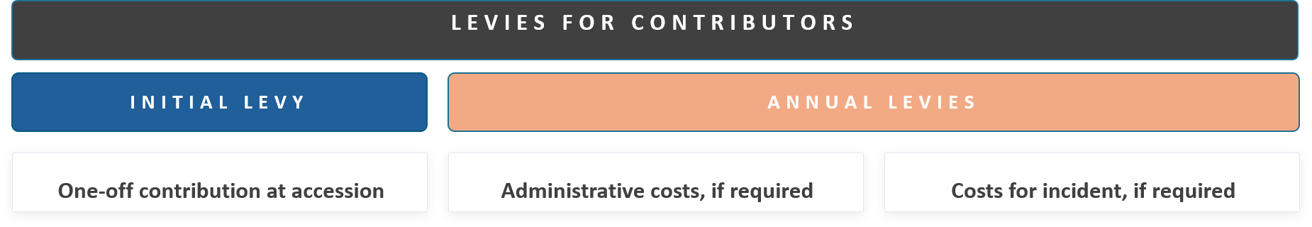

- Initial Contributions
Initial contributions will cover the setup costs for the HNS Secretariat, working capital for the HNS Fund to operate, and repayment of the loan from the 1992 Fund, which has financed HNS-related activities since 2011. The amount of initial contributions will be set by the HNS Fund Assembly and paid by contributors in each State that becomes a party to the Convention, regardless of when the State joins, so as not to penalise early joiners. The initial levy will be a fixed amount per unit of contributing cargo.

Apportionment of the Initial Levy
The initial levy is expected to be apportioned by dividing the amount that needs to be levied to start the Fund’s operations by the total amount of contributing cargo received from all contributors the year before the Convention enters into force, i.e. in 2026. This gives the levy rate. Each contributor pays the rate multiplied by their cargo volume received in the year before the Convention enters into force for their State. States that become parties after the Convention has entered into force must also pay initial contributions. These are expected to pay the same rate, applied to their first reporting year.
Indicative Initial Levy
The Secretariat anticipates that the costs of establishing the HNS Fund will be in the range of £5-£7 million. Based on reports provided by current Contracting States to the HNS Convention and projected figures for States that have committed to become parties, the estimated total contributing cargo at entry into force is between 500 million and 600 million tonnes. This scenario would yield a range of potential initial levy rate from £0.0083 per tonne at the low end to £0.014 per tonne at the high end.
Using a median estimated levy amount of £6 million and median estimated contributing cargo of 550 million tonnes, the indicative rate for initial, one-off, contributions would be £0.0109091 per tonne and indicative contributor costs would be:
- Annual Contributions
Administrative / Running Costs
Based on the IOPC Funds’ current HNS budget, annual administrative costs to support the operations of the HNS Fund are estimated to be between £550,000 and £750,000. These include a management fee that will cover staff costs and office infrastructure, including a share of the overhead of the IOPC Fund Secretariat’s office where the HNS Fund is expected to be co-located, as well as IT costs related to running the HNS Finder, reporting platform, and website, and outreach expenses.
Using an estimate in the middle of this range, £650,000 in annual running costs, and dividing by 550 million tonnes yields an indicative levy of £0.0011818 per tonne. Based on this levy, below are some example contributor costs for the annual levy:
In the early years, initial contributions from new entrants are expected to cover running costs, so no annual administrative levy is anticipated. As more States join and cargo volumes grow, the per-tonne rate is expected to fall. Note that annual contributions will only be levied if required. The HNS Fund Assembly will decide whether levies for administrative costs are necessary in any given year and apportion these costs across the general and separate accounts.

Cost of Incidents
In addition to the costs of running the HNS Fund’s Secretariat, annual contributions also cover the costs of providing compensation for victims. Incident costs cannot be predicted in advance, as they depend on the scale and number of HNS casualties, as well as the claims assessment process. The HNS Fund is divided into four separate accounts so that damages for incidents involving a particular type of HNS are paid for only by contributors to the relevant account. Costs will depend on the number of claims and the quantity of contributing cargo reported in that account at the time of the incident.
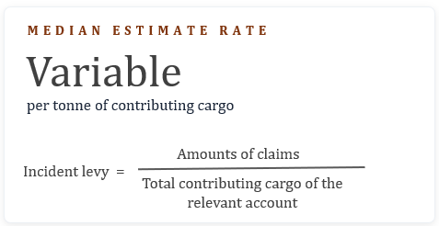

The HNS Convention creates a two-tiered liability and compensation system. The HNS Fund serves as a second-tier compensation and backstop for major incidents. Experience shows that HNS events exceeding the shipowner’s liability are rare, so industry contributions to the HNS Fund are expected to be infrequent and generally low.

With respect to the repayment of the loan, the Director has committed to developing options that will not penalize early adopters of the Convention. Depending on which option is chosen at the first meeting of the HNS Fund Assembly, the amount of the initial levy could be lower, though the full value of the loan will eventually have to be repaid.

